Assignment 2

Konrad Dittrich, Simon Spång

**Task 1:**

The answer can be found in the class astrobee under the method cartesian_ground_dynamics. It is implemented between the rows 68 to 74. See figure 1.

Figure 1 - A and B matrices

**Task 2:**

See the code in the file task2.py for the use of the methods casadi_c2d and set_discrete_dynamics.

**Task 3:**

The rendezvous constraints are declared as in figure 2.

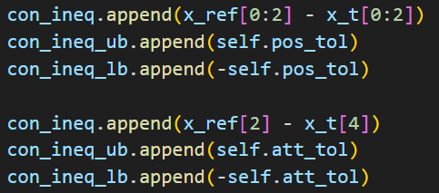

Figure 2 - Rendezvous constraints

Where $\overline{x_{ref}}=\left[\begin{matrix}P_{x} \\ P_{y} \\ θ\end{matrix}\right]$ and $\overline{x_{t}}=\left[\begin{matrix}p_{x} \\ p_{y} \\ v_{x} \\ v_{y} \\ θ \\ ω\end{matrix}\right]$

**Task 4:**

The simulation results in the trajectory plots, see figure 3. The goal state $x_{ref}$ is reached after ca. $t=25 sec.$ The system behaves as expected and specified.

Figure 3: Trajectory in x and y-direction

**Task 5:**

Since the thruster $u_{2}$ is broken the Force input is heavily disturbed. This leads to deviations in the control of the position. As a result, the reference state is not reached during simulation time. The root cause for this behavior is that the control is not able to compensate the deviations of the input signal of $u_{2}$ since the design of the control is not robust enough.

Figure 4: Trajectories with broken thruster u2

**Task 6:**

To fix the deviation in $y$ caused by the noisy $u_{2}$-signal we could add a feedback-loop, since this additional policy can reduce the effects of unforeseen disturbances and make the control more robust, see Lecture Chapter 3.1.

**Task 7:**

The model is to be extended by the third dimension by expanding the *cartesiana_3d_dynamics*-function. The trajectories are plotted in figure 5. A new controller *ctrl_wz* is used which needed 3.73 sec to obtain a solution. The 2d-simulation took 0.52 secs.

By comparing the simulation in 2d- and 3d-setup a reasoning for the increase of computation time is found, see table 1. By adding a third dimension, which means two more state variables and one more input variable, the number of variables through the whole calculation is increased 1.78 times, the constraints raise by factor 1.33 and all other matrices and calculation entries are more than doubled. As a result, the computation time increases by factor 7.17.

Table 1: comparison of 2d- and 3d-simulation setup

|  |  |  |  |
| --- | --- | --- | --- |
| ­ | 2d-simulation | 3d-simulation | Factor of increase |
| Number of variables | 2706 | 4808 | 1.78 |
| Number of constraints | 2853 | 3804 | 1.33 |
| Number of nonzeros in H | 2700 | 6400 | 2.37 |
| Number of nonzeros in A | 19053 | 42204 | 2.22 |
| Number of nonzeros in KKT | 45465 | 97820 | 2.15 |
| Number of nonzeros in QR(V) | 43467 | 97932 | 2.25 |
| Number of nonzeros in QR(R) | 84111 | 180124 | 2.14 |

Ein Bild, das Text, Diagramm, Reihe, parallel enthält.

Figure 5: Trajectory and control for the 3D-system